​​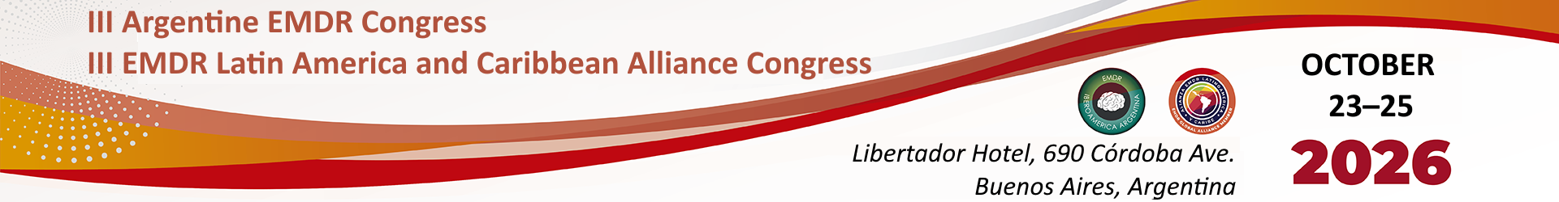

By means of this document, I declare that the professional ______________________________________ has informed me of his/her intention to disclose my clinical case for purely academic purposes at the III Argentine EMDR Congress and the III EMDR Latin America and Caribbean Alliance Congress, using the information that I have truthfully provided at the time of admission, day-hospital treatment or outpatient treatment, and which has been recorded in the clinical record. I have also been informed that my identity will not be disclosed.
It has been clearly explained to me, and I fully understand, that my approval is given free of charge and voluntarily, and that I do not waive any of my rights by giving it. Furthermore, I may revoke and withdraw my authorization at any time, without this affecting my treatment in any way.
In view of the foregoing, I authorize the reproduction of the aforementioned information for academic purposes within the framework of the III Argentine EMDR Congress.

Date:
Place:
Signature:
Printed name:
National ID (DNI):

Professional’s signature:
Stamp and license number:

NOTE: Send this document by email to congreso2026@emdribargentina.org.ar.

